Airline Booking System
Investigation
George Cooke
2026/27

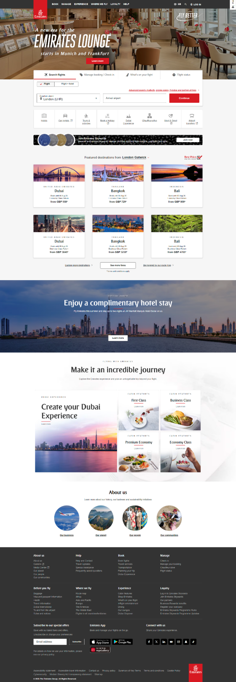
Desk Based Research

Competitor #1 – Emirates
Emirates is likely one of the closest competitors for Infinity Airways as it also targets the more luxury end of airline travel. They place their attention to detail and luxury in plain view when navigating the website. That said, they also target individuals with a lower income (by comparison) with some of the advertisements for economy class showing off the multitude of extras that come included with the fare which gives a sense of value.

Shown to the right is the main landing page for Emirates when entering from the UK.
One can see that it is immediately pushing users to book a flight as frictionlessly as possible. It has been proven that the likelihood of a customer making a purchase decreases by 30-50% with each additional click that they have to make. This statistic was likely researched primarily for smaller purchases, but Tesla has seen success in increasing the chance of purchase by reducing the number of clicks which proves that this can also be applied to larger purchase, its stands to reason that this can also be applied to airline tickets. I will take inspiration from this and make sure that y website pushes users to purchase a ticket from the index page. When booking from this section, it automatically selects a return trip whereas booking from the main booking page allows for the selection of return, single flight, or multi- city.
Emirates also has tabs immediately displayed to the user for checking in for a previously booked flight, viewing the amenities that are available for a given flight, and checking the status given for the flight (delays, cancellations, etc.). I will defiantly endeavour to include a flight status section that is easily accessible and may add a stretch target for the addition of a check in from this page (I was originally planning to make the user log in to view all of their flights but I could also add a search by booking ID).
Emirates then follows this section with a popular routes / destinations section. This is similar to what I was planning to do with my articles section. There are also sections more akin to my articles idea when you navigate to WHERE WE FLY → Our Destinations → <any area> → <any country>.
This is then followed by Emirates’ sales pitch for why to fly with them where it directs a user to their “experience” pages that talk about all the ways that Emirates excels. I can try to add this to my designs.
The menu at the top of the page is fully responsive and turns into a hamburger menu when the page is too narrow. It is interesting to note that when viewed on a mobile device, the tab for quickly searching for flight disappears in favour of larger buttons for selecting the different tabs which redirect to different pages.

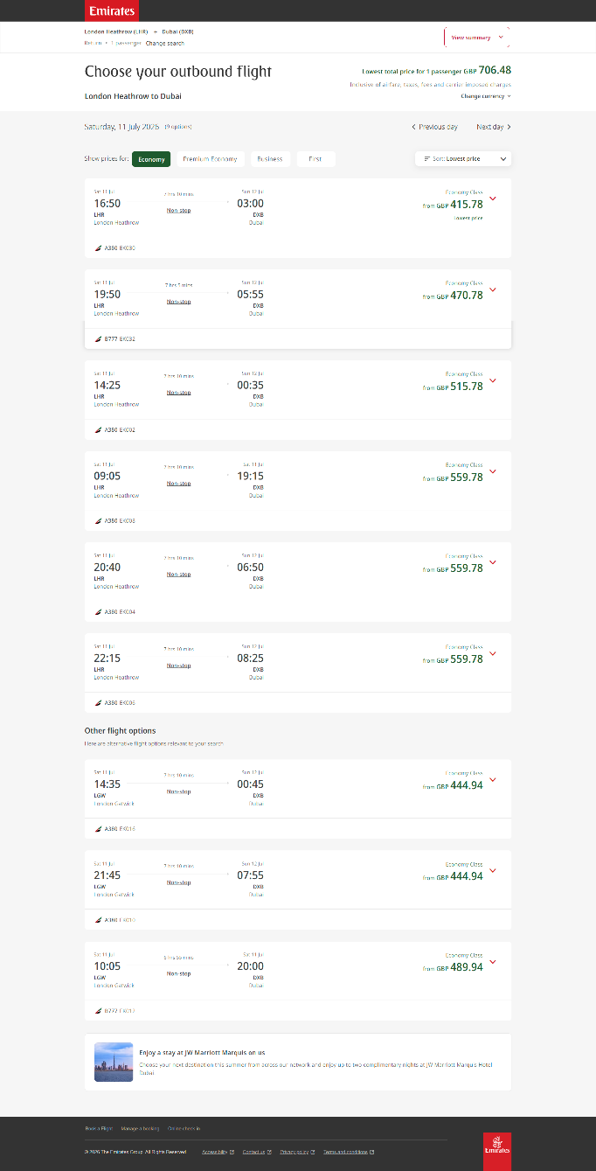
Having searched for a flight, a user is presented with a list of possible flights that fit their parameters.
The key information for each flight that it presents a user with is:
- Departure date / time (local),
- Departure airport,
  - IATA code and name,
- Information about layovers / changes,
- Length of flight (time),
- Arrival date / time (local),
- Arrival airport,
  - IATA code and name,
- Class selection,
- Price,
- Aircraft type,
- Flight number,
Users can also select their desired class from this page and it will autofill it when they go to book tickets. This helps to display the most relevant prices to the user and reduce clicks later in the process of booking.
The flights are sorted by price automatically but there are options for:
- Arrival time,
- Departure time,
- Duration,
- Miles earned,
A user is also given the option to shift their date of departure day by day in either direction at the top of the page so that that don’t have to go back and re-enter their details if they want to shop around for other options.

Under the section that displays exact matches, there is a section that shows similar fights from nearby airports. This is similar to what I intended to do as one of my stretch targets.

If a user loses their page with their booking options, they can press the back button in their browser to return to it. This seems to work using a randomly generated code for the search query in the URL. This references an index in their database that is held for a short time. After this time, the search record is removed from their servers in an effort to save storage space. This is an effective way to make the program easier to use without too much complexity. That said, I think I can improve upon this by having my search terms in the URL instead of having it direct to a record. This will mean that the data is kept with no storage requirements from me. That said, this may mean that users see different results each time they refresh whereas Emirates’ way ensure they remain consistent. This may also mean that users see different process with each refresh if dynamic pricing is implemented which may give a sour impression.
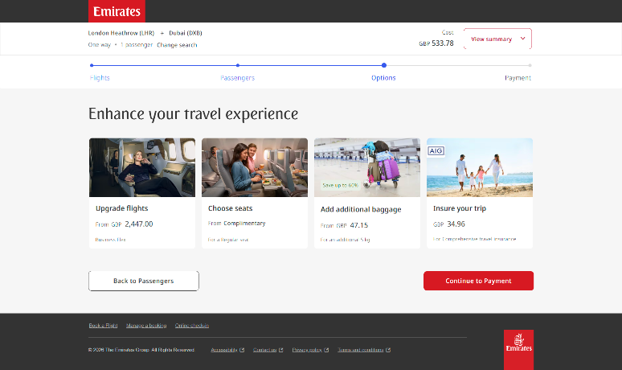
Having selected a flight and entered passenger details, a user is offered the following upgrades:
- Upgrade class,
- Choose seats (free),
- Add additional baggage,
- Insurance,

At this point, a user is likely already invested in the purchase of the plane tickets which means they are less likely to leave when advertised to. This is a cleaver way to try and upsell the customer and I will likely try to implement it in my own solution.

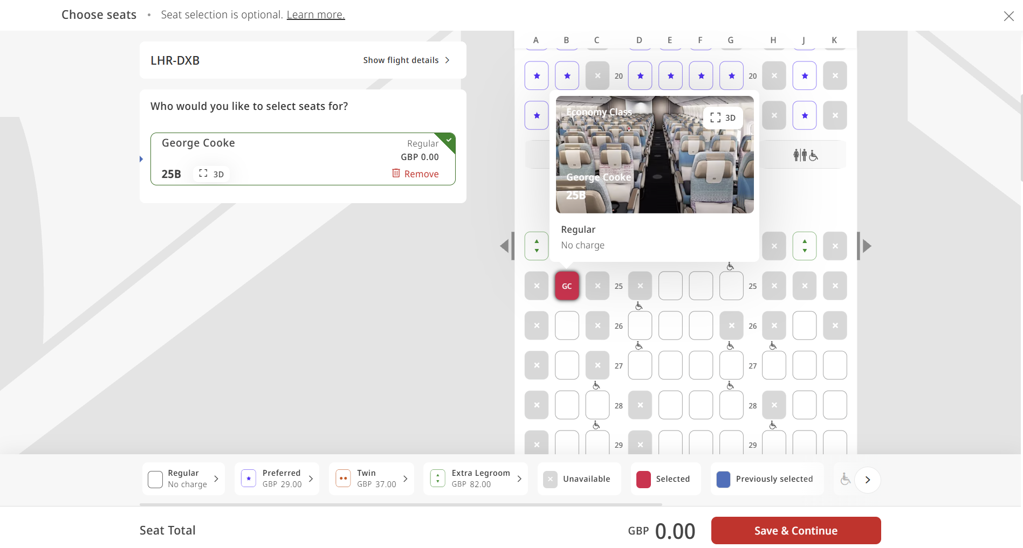
When selecting seats, the user is shown all of the available seats for the class that they selected. Booked seats are marked with a cross and premium seats are shown in different colours. You can also see the initials of the person that is booked on to each seat so it is clear who will be sitting where. This is better than many other solutions that make it unclear. There is also a 3D view of the cabin - this doesn’t provide a great deal of value, causes lower powered machines to lag, and is complicated to implement so I almost certainly won’t be adding this to my solution.

When paying, users are given options to pay in full, pay with miles settle what is left with cash, or use buy now pay later options. I will likely have the pay in cash and pay with miles options available but will forego buy now pay later as it does not fit with the brand identity of exclusivity that Infinity Airways is trying to cultivate.

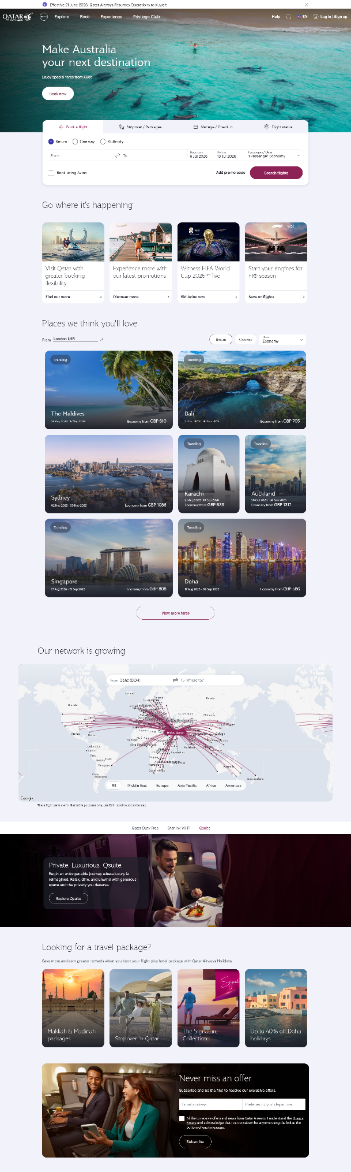
Competitor #2 – Qatar Airways
Qatar Airways is another higher end airline that target middle and upper class passengers as well as business professionals.

Like Emirates, they have their flight search widget in a prominent position on their main landing page. This also has options to have stopovers, manage booked flights, and check the status of flights.
This section is followed by a popular destinations section each of which gives a user the option to either book straight to the location or discover more about it (similar to the articles feature I was planning).
This is followed by a route map. While this could be interesting, I don’t think it would add much to my project so will likely not be implementing it in my solution.
After this is a section on several of the amenities that Qatar Airways offer. This is an advertisement banner to promote their services over their competitors.
This is followed by a travel packages section to offer discounted and bundled flights. While this would be good for most airlines, I don’t believe that it aligns with the audience that Infinity Airways will be aiming for as they will want complete control over their time and will be prepared to pay a premium for it.
Finally, there is a section where a user can subscribe to their newsletter for updates. This could be added as a part of the stretch target to implement automated emails.

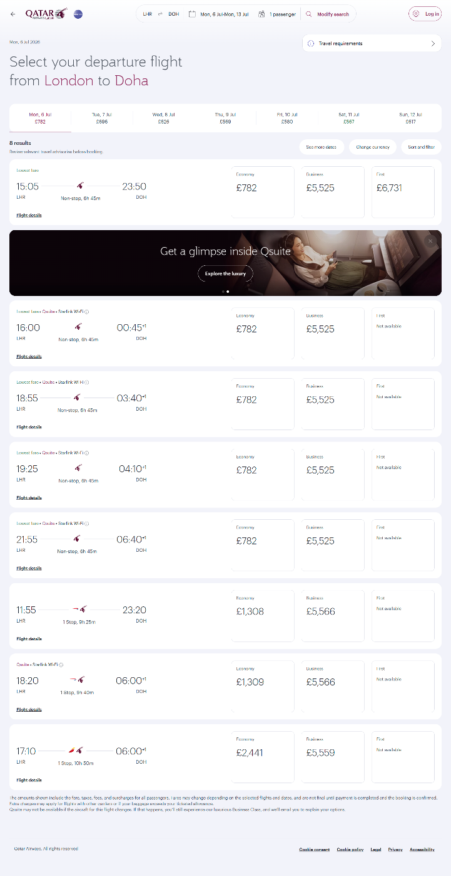
Having searched for a flight, a user is met by the screen to the right.
The top of the screen shows all of the available dates in the week of departure that the user selected with the minimum price available for that day. Each flight card has:
- The local time of departure,
- The local time of arrival (and the time zone difference),
- The length of the flight,
- A tally of how many changes there would be,
- The IATA code of the departure airport,
- The IATA code of the arrival airport,
- The price of the flight,
  - Only economy if on a narrow screen,
  - Economy, business, and first if on a wide enough screen,
    - These appear having clicked on a card to expand it if the screen is not wide enough,
- A link to more details about the flight,
  - This opens the modal show to the bottom right,
Flights are ordered here first by lowest price and then by ascending time of departure in the event that there are multiple flights of the same price.
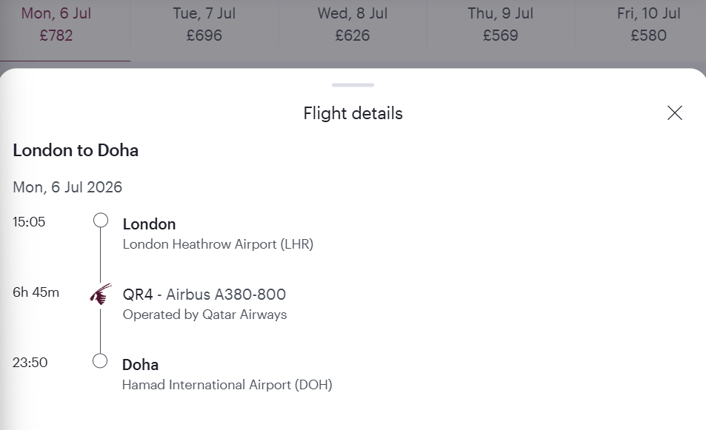
I like that this screen is broken up by the advertisement on the second row. It makes the page feel less repetitive and as a result it feels more digestible. I also like the minimal use of different colours used head compared to the Emirates equivalent as it makes it seem more understated.

Having progressed from the flight selection page, a user is prompted to enter the details of the given passengers. The details requested are:
- Title,
- Gender,
- First and middle name(s),
- Last name,
- Date of birth,
- Nationality (searchable),
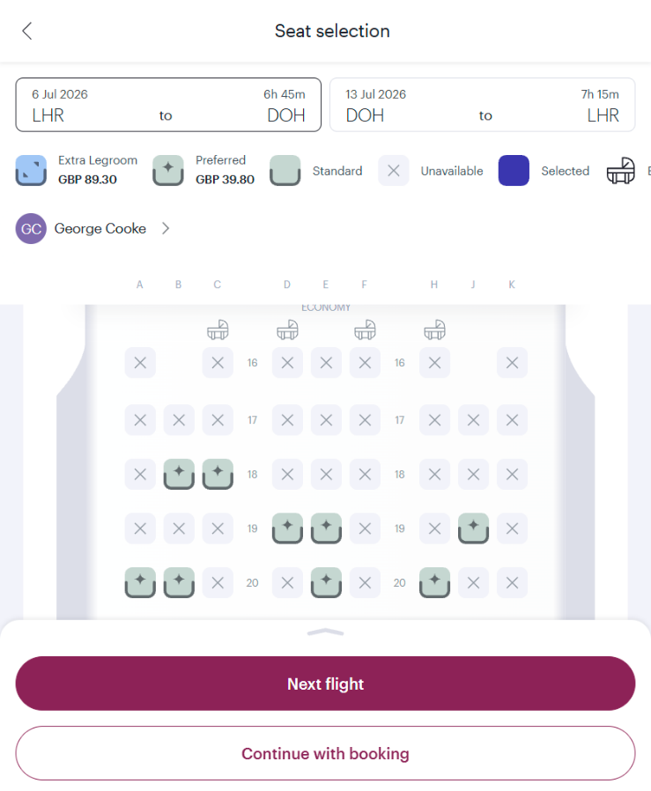
Having entered one’s details, a user can progress to the seat selection and payment section. The seat selection page is show to the right.
The two flights selected (outbound and return) are shown at the top of the page to remove friction of switching pages to book seats for each of the flights.
Toilets and galleys are clearly marked so that a user can make arrangements to ensure they have easy access or meal priority if they so please.
Having selected a seat, the passenger’s initials are shown over it. A user can also click on the seat again to unbook it instead of having to cycle through a carousel like you do with many other solutions.

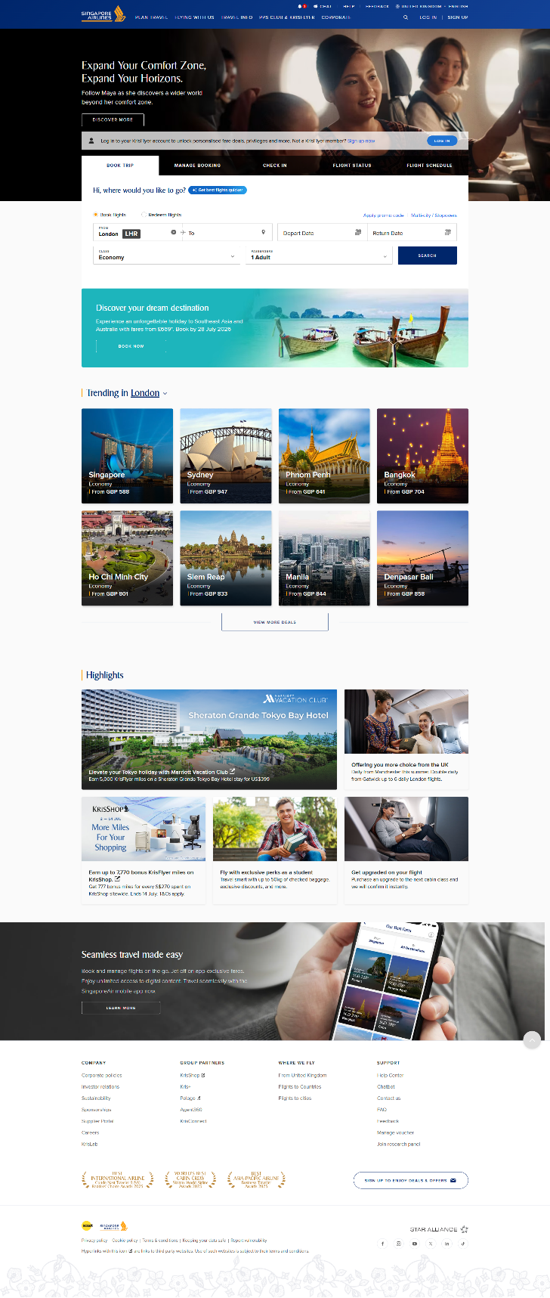
Competitor #3 – Singapore Airlines
Singapore Airlines is another premium airline that targets business and leisure passengers that are prepared to pay a premium for luxury and comfort.

Pictured to the right is the main landing page for Singapore Airlines. As with all of the previously studied competitors, the user is first met with a flight search card to remove as much friction as possible in the process of finding a flight to book. Also like Emirates, this turns into a number of larger buttons on narrower screens to go into separate pages to make it easier for mobile use.
This section is followed by a collection of popular destinations for passengers coming from London accompanied by images of the location and a price for travel there. This is similar to my articles idea but lacks the longer text description that I was planning to implement.
Finally, there is a section advertising articles on all of the amenities that Singapore Airlines offers. This promotes their more premium features in an attempt to both win customers over and persuade them to upgrade to more expensive seats.

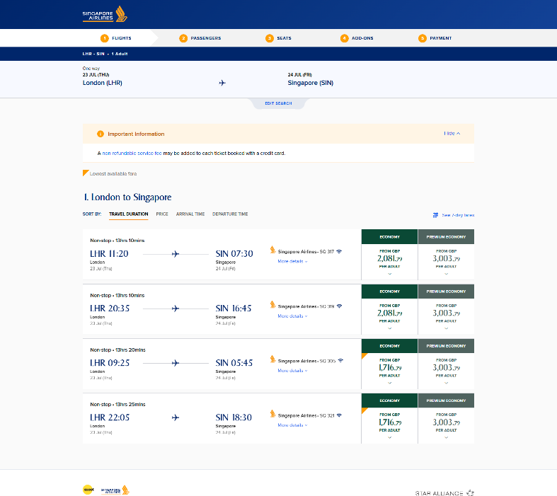
Having searched for a set of flight details, a user is met by the screen to the right. This shows a list of all the valid routes that a user can book on to given the search criteria specified. By default this is sorted by duration but can also be sorted by: price, arrival time, or departure time.

The key information displayed is:
- Number of layovers,
- Flight duration,
- Departure airport IATA,
- Departure airport local time,
- Departure airport city,
- Departure airport date,
- Arrival airport IATA,
- Arrival airport local time,
- Arrival airport city,
- Arrival airport date,
- Flight number,
- Price,
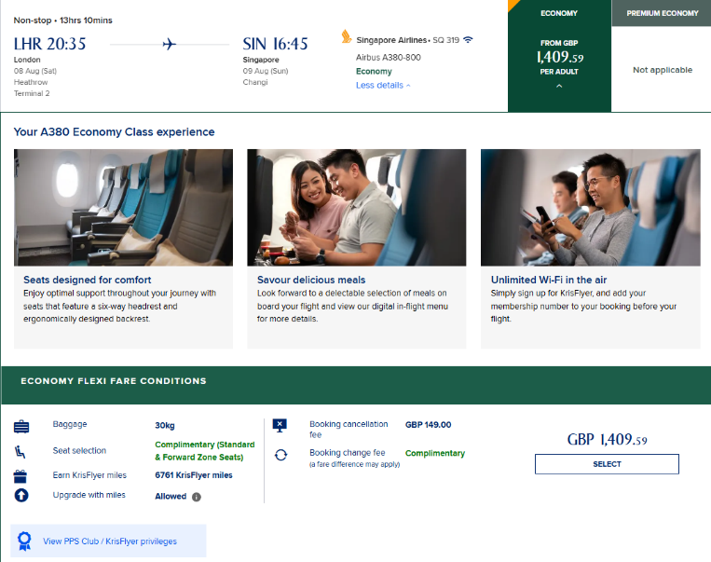
Having selected a flight, the flight card expands to display the options shown to the right. This shows three of the ammenities included with the flight (seats, meals, and Wi-Fi). It also displays the baggage allowance, number of miles that will be given, and cancelation fees.
I feel that I could improve on the call to action here where the “SELECT” button is small and easy to miss. This may reduce the chances of conversion. I will cretae a standard CTA button syle in my CSS and assign it to all of my booking buttons.

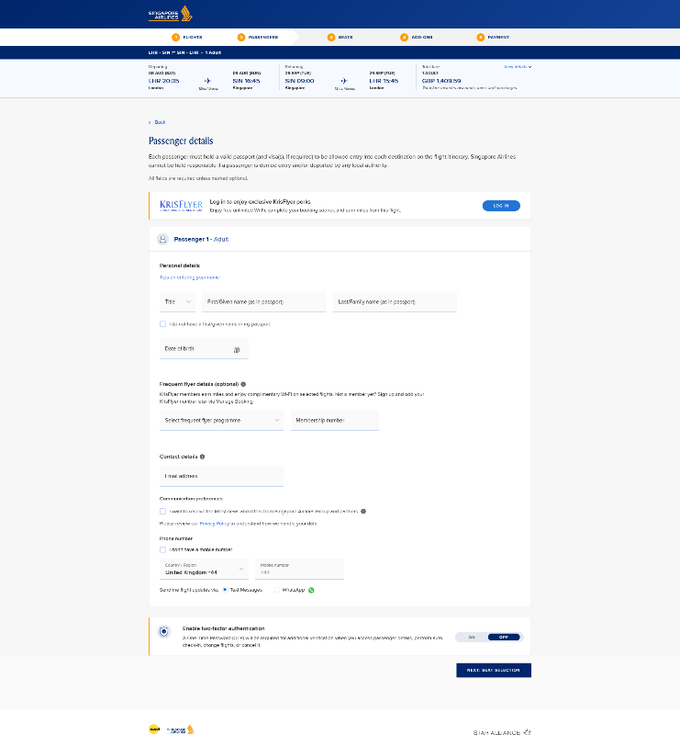
Having sleected the flights that a user would like to book, they are directed to enter their personal details in the page pictured to the right.
This page does not prompt a user to create an account or opt in for marketing emails. I view this as a missed opportunity as it may reduce the chance of getting a repeat customer from any given interaction.

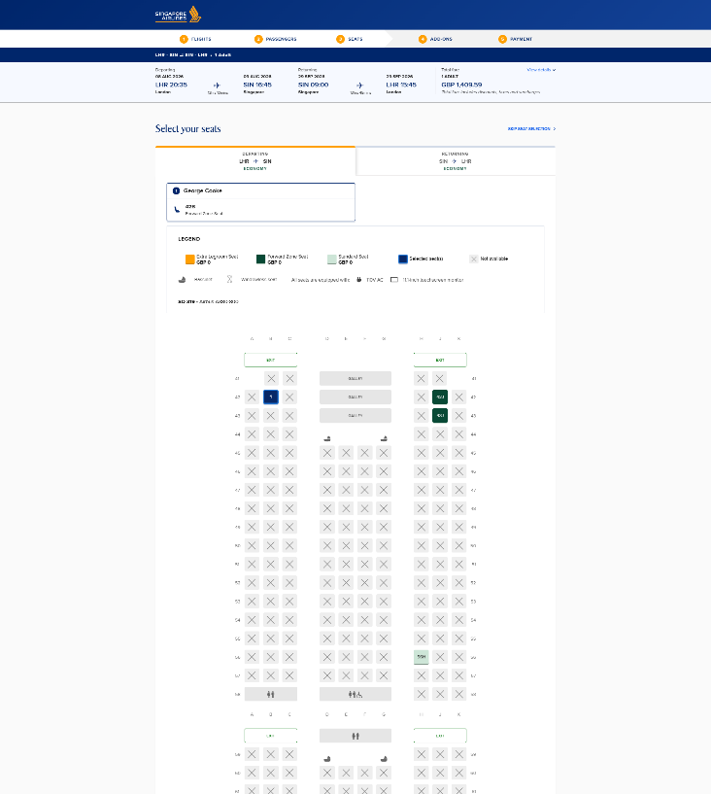
Moving on from this, a user is given the opportunity to book their desired seat(s) in the page pictured to the right (cropped for the sake of brevity).
This page gives the user the opportunity to view all the available seats in their class for each of the selected flights (outbound and return). As with a number of other analysed competitors, if a user is not happy with a choice for a passenger they can select that passenger and jump straight to override their seat (some competitors force as user to cycle through and change the seats of everyone until they can change the seat of just one).
The seating map on this page is unique to the aircraft configuration and clearly displays the different types of seats as well as which are already booked. It also shows where the galleys and restrooms are located.

After selecting seats, users are given a number of optional extras that they can add on to their booking (such as additional baggage). At this point a user is more likely to be committed to booking with Singapore Airlines and will be less likely to switch to a competitor when advertised to. This reduces the risk to the airline of more aggressively pushing their optional extras.

Stakeholders

Flight Operations Managers
Flight operations managers are the users that add routes, services, and flights. They will not need to do much beyond this but will want supporting analytics to know which routes and services are performing well. They will want to be able to see the proportion of seats that are filled on flights, routes, and services. They will also want to see the revenue figures for specific routes, flights, and services as well as overall for given periods of time. This will allow them to make more informed decisions for where to create routes and expand to ensure flights do not go empty.

Guests
Guests will want to be able to book flights for set dates and times to and from set locations with the confidence that their seat will be reserved. They will want as streamlined a process as possible given their higher net-worth status that allows them to go to any number of competitors and the limited time that they are expected to have.

Check-In Agents
Check-in agents are the members of airline staff that print boarding passes if not already printed upon guest arrival and take backage to be loaded into the hold of the aircraft. Many airlines are cutting back in these customer facing roles in favour of electronic replacements. Infinity Airways will likely elect to keep them to appeal to its luxury target audience; they will be greeting guests and ensuring that they feel welcome. As such, they will have to be able to see all of the flights scheduled to depart from their assigned airport and all of the passengers booked on to the given flights so that they can give as much support as possible.
They should also be able to mark guests as arrived and their luggage as taken as well as view a basic overview of the guest’s flight. This will ensure that they can render assistance to the guest if required.

Gate Agents
Gate agents are the members of airline staff that check boarding passes when entering the aircraft and mark passengers as boarded on the flight. Their primary needs will be the ability to view passengers booked on to flights and mark them as boarded (this list of passengers should be searchable). They should also be able to see other details about the boarding pass to check against the printed ticket to check that it is legitimate (a unique ID for example).

Customer Support Representatives
Customer support representatives are the users that offer tailored support to guests. They are each assigned a collection of guests that are their sole responsibility. They will be able to view and make bookings on the behalf of their assigned guests and do everything in their power to make sure that they are taken care of.
They will need to be able to view the details for their guests and make changes on their behalf. They may also find it helpful to have an inbox section that tells them the changes that their assigned guests have made themselves and the flights they have booked themselves on to. This would help them to keep up to date with the actions of their guests so they can offer the best possible standard of care.

Admin
Admin users will be the ultimate overseers of the program. Their primary responsibility will be to add new staff users and edit their type / permissions / login details. They will also have the ability to delete guest accounts.
While this is their primary responsibility, they will also have access to all of the other portals for all of the other user types listed above. This is so that if a mistake is made or there is an issue, the admin users can diagnose and fix it.

Existing System

Questionnaire
As a part of my investigation, I sent a questionnaire out to 100 people that frequently travel with luxury airlines; I was fortunate enough that 87 of them replied. My questionnaire contained a total of 8 questions that I designed to get an impression of who would be using the booking website, how they would be using it, and any of their expectations.

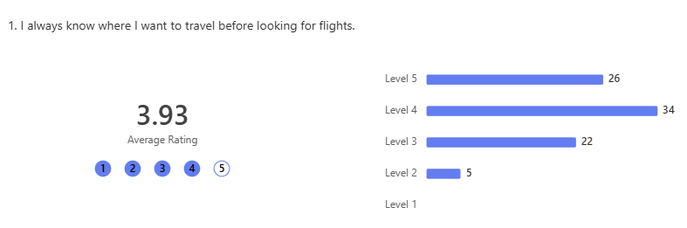
Above was the first question in my questionnaire. This indicates that the majority of potential guests will have a keen idea of where they want to travel before they come to our website. That said, there remains a collection of people that may look at our website before settling on a destination. It is hard to tell if this is because they are simply looking for inspiration or if they are looking for the cheapest flights. My assumption would be that it falls within the former on account of the high income and net worth of the individuals the form was sent to.
These results show that the majority of development focus should go towards the booking process but that there remains a desire for the articles section to inspire prospective guests.

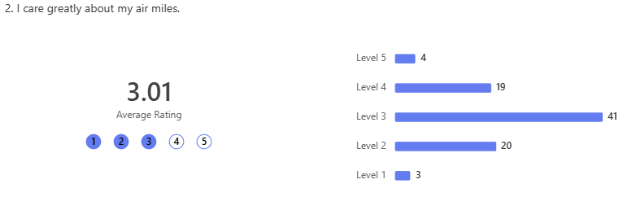
The above response shows that responders are evenly split on the extent to which they care about air miles. This could be as a result of growing distaste towards the over commercialisation of air travel in many higher income travellers (as was suggested in my discussion) conflicting with a strong desire to save money and maximise value.
This suggests that miles should be added if there is any spare time in the development process but they should not be a primary focus.

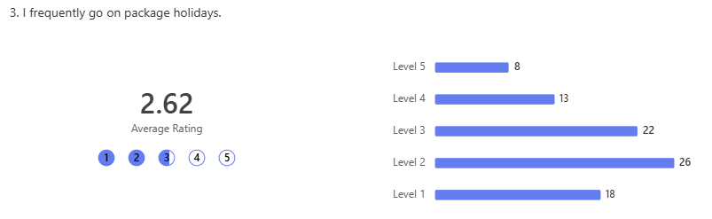
This suggests that most higher income clients err away from package holidays as 20% of respondents suggest that they never travel on package holidays. This may be as package holidays tend to cater to a more mass market and budget audience. That said, a higher proportion of respondents indicate that they do travel on package holidays than was initially expected. This may suggest that a potential expansion for Infinity Airways would be the offering of these package holidays.
Despite this, this is unfortunately likely to be outside of the scope of the project in its current state.

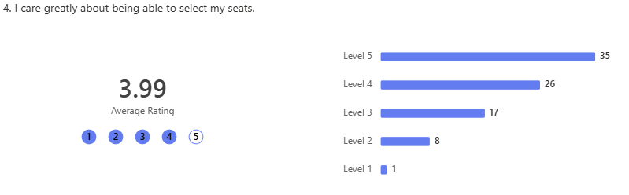
This question indicates a strong preference for guests being able to select their seats. This was expected even if not quite to this extent. This likely comes as guests have window/isle seat preferences and want to be seated net to other people in their group.
This response reenforces the importance of guests being able to select their seats and that this should be a key feature of the website.

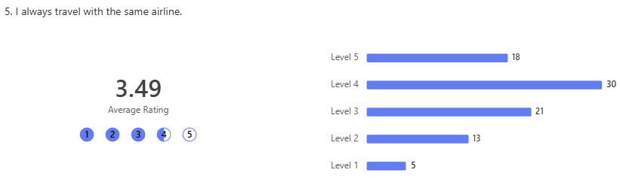
This response indicates a strong brand loyalty among travellers in the higher income and net worth bracket. A part of this may come from the proportion of high value travellers that value air miles (as indicated in question #2) combined with the freedom afforded by increased disposable income.
This may suggest that it will be hard for Infinity Airways to break into the market without an incredibly strong USP.

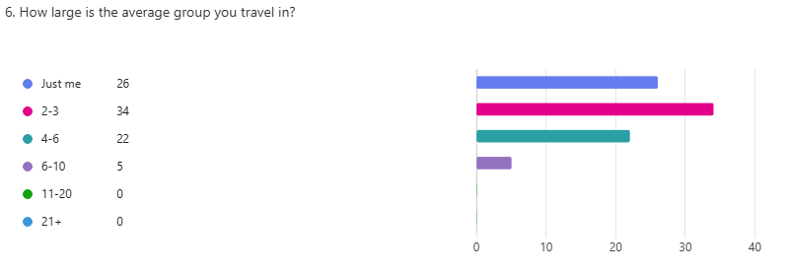
This response shows that most travellers will travel in groups of 2-3 with 94% of respondents travelling in groups smaller than 6 people. This comes as respondents travel on their own or with assistants for business and small family groups for holidays. The complete lack of groups of 11 or more people may suggest a shortcoming in the distribution of the survey as it may not have sufficiently been sent to the ultra-high net worth individuals that own/charter larger private aircraft such as the 737 BBJ (and other Boeing Business Jets) which has a seating capacity of 40.
This response pattern indicates the importance of being able to seamlessly book for groups of people (view the Observation section for the shortcomings of how this is done in the current system).

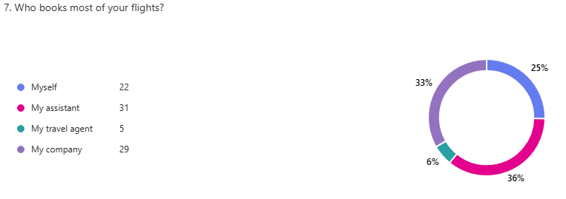
This question indicates that the majority of respondents (75%) do not book their flights for themselves. The 29 respondents that’s say their company books the majority of the flights show that a large number of Infinity Airways’ guests will be travelling on business. This indicates the importance of Infinity Airways forming good relations with companies though consistent reliability and outreach programs.
This question also indicates that 37% of flights are likely to be booked by the personal assistants of the guests. This gives a keen insight into the kinds of people using the website and may mean that users are less likely to switch to competitors and minor inconveniences. That said, the 25% that do book their own flights mean that the seamlessness of the website must remain a priority.

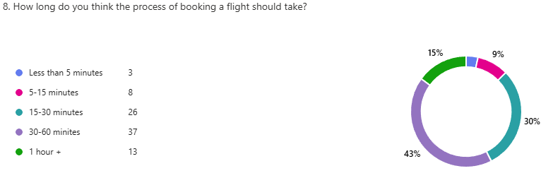
This question gives us a good insight into the baseline expectations of individuals booking flights. This shows that 43% of respondents expect the process to take 30-60 minutes (note that this may be how long they expect it to take someone else to book if they are a member of the 75% that do not book their own flights). This combined with the 15% that expect it to take longer than an hour indicates that even among the wealthier members of society booking air travel is expected to be an arduous and time consuming task.
This could indicate that there is a gap in the market for a painless and seamless booking process. A well-designed website may be the USP that Infinity Airways needs to quickly break into the luxury air travel market. This proves how much of a priority the usability and reliability of the website should be.

Observation
I was fortunate enough to be able to sit in on an event within Infinity Airways in which they simulated a day of typical operations. This was intended to identify potential shortcomings and failures of service before launching the business to the public.
At this time, all airline operations relating to the scheduling of flights and then the booking of them was done manually in Excel when potential guests called the airline. This was a clear shortcoming as it could not work at scale and introduced a risk of human error in the inputting of data to the spreadsheet.

I feel that the best way of identifying how things were operated and the shortcomings of this method would be to guide the reader through the steps that were taken when someone was attempting to book a flight.

Step 1 – The Guest Calls the Airline:
In order to make a booking, a guest must call the airline. This causes friction as guests may struggle to find the phone number. This would substantially reduce the number of people that go to the effort of booking with Infinity Airways as they take the more convenient route by booking with one of the many alternatives.
Even after finding a phone number, prospective guests were likely to end up on hold while they waited for a customer support representative to become available to take their request. This introduced further friction that yet further increased the odds of them switching to a competitor. This waiting time would only increase at scale as a greater number of prospective guests would want to book simultaneously. If Infinity Airways were to try and hire more customer support representatives to cope with this scale, it would come at great operational expense reducing the viability of the business.

Step 2 – The Guest Inquires About Flight Availability:
Because there is no online list of routes or flights, a guest calls the airline blind. They will have to enquire as to the routes available and the flight times. In order for the customer support representative to answer this question they must manually search through a long list of routes in a spreadsheet. This was a mammoth task in of itself as flights are ordered by date and time of departure (not route), so they have to manually search the list. Automated search becomes harder as departure and arrival airports are in different fields. This would force a Customer Support Representative to use an XLOOKUP function for each query. This is time consuming and prone to human error.

Step 3 – The Guest Attempts to Book on to a Flight:
Even having found a viable flight, it is not guaranteed that there are seats available. While the rotes sheet has a field for seats available, many customer support representatives forgot to decrement this when booking a guest. This left many prospective guests disappointed and further increased the chances of their switching to a competitor.

Step 4 – The Guest Books a Seat:
Having finally found a viable flight with spare capacity, a guest must select a seat. To do this, the customer support representative must switch to a separate document that us unique for that specific flight. There they must navigate to the seats sheet and scan through it until the find a seat number that has not been filled with the information of a guest. As with all of the other steps in this process, this takes time.
To book the seat, the customer support representative must input all of the guest’s information next to the seat number in this sheet. This introduces the potential for data redundancy and inconsistency. This data redundancy comes as guest information has to be put against every seat that the guest books regardless of if they have already booked with the airline. This leads to increased storage requirements and makes it all but impossible to search for all the bookings of a guest. Data inconsistency comes as different customer support representatives use different abbreviations in addresses, misspell entries, and/or mishear clients over the phone as they give their information. We found in this event that almost 80% of records had at least one error with 10% being completely invalid and thus unusable.

Questions:
During my observation, I had the opportunity to ask a number of questions of the customer support representative I was shadowing.

What is your least favourite thing about the current system?
Their biggest gripe with the current system was that they were constantly taking calls from new potential guests. They felt that this gave them a pitiful amount of time to get to know the guests assigned to them which meant that they could not provide adequate support when their guests called in asking for help with their existing bookings.

What is the most common mistake when booking a guest?
They said that forgetting to decrement the seats available for the route was the biggest issue among the whole team.

How do you currently handle cancellations?
They described simply deleting all of the information next to the seat in the flight spreadsheet and incrementing the available seats in the routes sheet.

How do you handle group bookings?
They described having to put information next to the seat in order to reserve it but said that each representative did it a different way. Apparently, some representatives put the information of the individual booking next to each seat. Others will put the information of each passenger but keep the contact information the same for each of them. You can imagine that this made it impossible to delete a whole group when information linking them was missing. Sometimes it would even go so far as the less engaged representatives only putting the names of the other members of the group and not bothering to type the extra information. This meant that guests could not be contacted if issues arose with their flight or booking.

Interview
For my interview, I interviewed Steven – one of the flight operations managers for Infinity Airways. A summary of this interview can be found below:

- Steven first described to me a summary of what his job was:
  - When it boils down to it, it is his responsibility to decide which flights to create and continue,
  - This is critical to the function of the airline as the accurate choosing of routes ensures that flights are fully subscribed leading to the highest profit margins possible for the airlines,
- He then went on to describe the current system to me:
  - They work primarily in the “Flights” Excel document,
  - The document is not setup to show graphs of the performance of different flights,
  - Flights are not linked to routes,
    - This means you have to manually search through the whole document if you want to see the performance of all the flights for one route such as Heathrow to JFK,
  - To decide which flights to repeat, flight operations managers have to scroll through the list of flights to see which have the fewest seats available,
    - This depends on customer support representatives updating the seats remaining figure,
      - Steven was surprised when I told him about my observation of the customer support representatives that frequently did not do this,
    - It can be easy to miss which flights do not have seats remaining,
    - A flight not having seats remaining does not mean that another flight has not already been made to add extra capacity to the route,
      - One full flight can mean that five new flights are made as all of the flight operations managers scramble to take care of the lack of capacity without coordinating,
    - They have no way of knowing which times are the most popular for flights,
  - Flight operations managers have no indication of the revenue or profitability of flights,
    - This means that they cannot make informed decisions to best support the airline,
  - There is not way to setup regularly repeating schedules in the Excel document,
    - This means that every flight has to be manually created,
    - This can lead to a Flight Operations Manager forgetting to create a flight in time for guests to book on to it,
  - There is no way to get feedback on the success of the flights that a flight operations manager has created,
    - This can make it hard for team leaders to know which flight operations managers need the most support and additional training,
- To wrap up our conversation, we talked about the features that Steven would most like to see in the system that we are making. These are ranked in descending order of priority below:
- Scheduling flights,
- A way to view all of the active flights for a route,
- Graphs to indicate the performance of different flights/routes/schedules,
- Feedback on the performance of flights/routes/schedules created,
- Accurate reporting on the spare capacity of flights/routes/schedules,

Document Collection
During my time with Infinity Airways, I found many of their spreadsheets to be lacking critical details. This is understandable as the event was only a first mock for an airline that hasn’t even had a chance to start to find a footing.
As such, I feel that it would be prudent to do my document collection based on another airline (British Airways) that has had a significant amount more time to ensure their systems hold all the data that is needed both for normal operations and when things go wrong.
For this document collection, I will need to make note of not only the data a user inputs but also the flight data that is stored to indicate what is requested of flight operations managers.

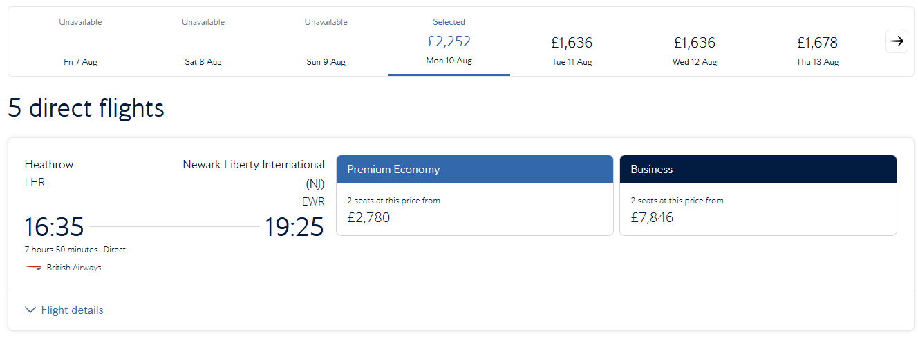
Above is an image of the information displayed when selecting a flight. This is likely to be stored in its own flights table. It can clearly be seen that there must be fields for: date, departure airport and arrival airport. There must also be a field for departure time but I have no way of knowing if this is stored as local time or UTC.
The duration of the flight is also displayed; I have no way of knowing if this is stored simply as a duration of time or if the distance between the airports is stored and a flight time calculated from that. I would assume that flight time is the data that is stored as I see on the website that even on the same route it can vary (there was on Heathrow to JFK flight that was scheduled to take 07:55 and another scheduled to take 08:00). This would make sense as even on the same route flight paths can vary between flights and differing winds can lead to differences in ground speed.
The price of the flight is also displayed for different classes; I have no way of knowing if this is stored in the database or dynamically calculated with live prices that change with demand. I will most likely store mine as fixed values in my database and only add dynamic pricing at a later date if there is time available at the end of the project.
I will also need to store a flight number and aircraft type in this table so that I can display the correct seat map (different seat maps for different aircraft is a bonus feature planned to be added at a later date if there is time spare).

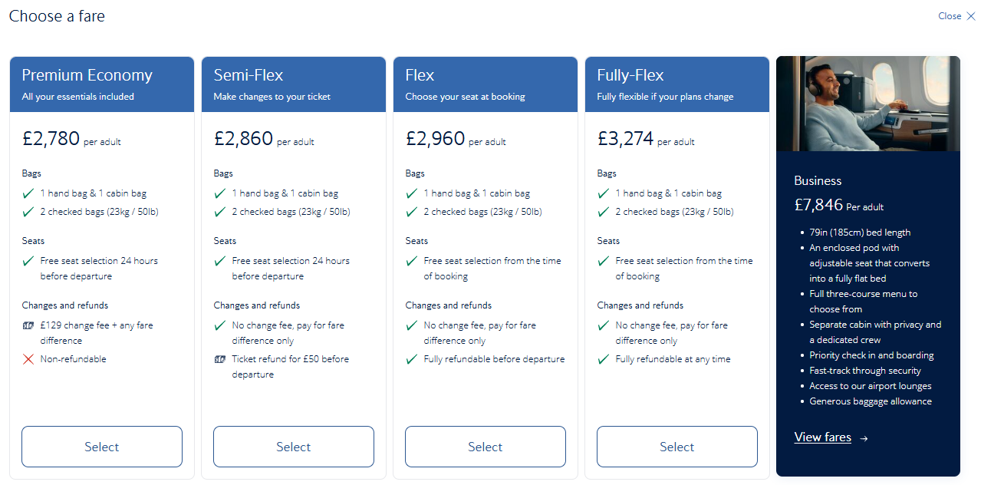
The above page is shown when selecting a class. This shows all of the different perks with various classes of travel. This is likely stored in its own table where perks depend on the class of travel and the aircraft. I will likely hard code this at first but may add it as a stretch or target objective to store this in its own table.
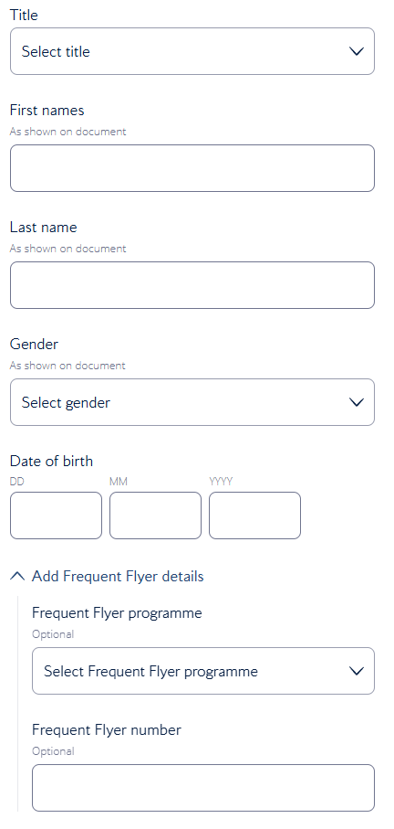
Shown to the right are the two forms on the following page asking for all of the details of the passengers.

They asks for:
- Title (dropdown),
- First name,
- Last name,
- Gender (dropdown),
- Date of birth,
- (Optional) frequent flier program,
- (Optional) frequent flier ID,

- Email,
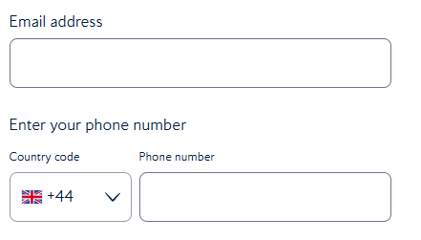
- Phone number,

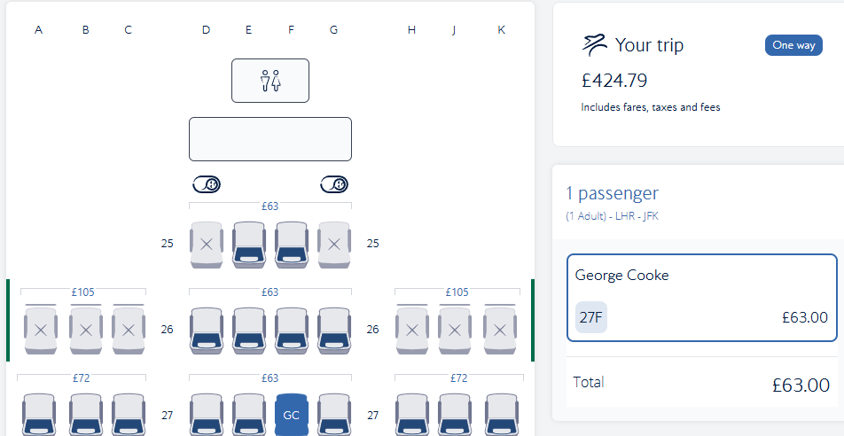The next page is the seat selection page shown above. I would assume that this is a dedicated table that has a foreign key for the booking and another foreign key for the passenger acting as a bridge table to break up the many to many relationship (a passenger can have many bookings and a booking can have many passengers). This table will also have the seat number stored in it which will link to the seat map of the given aircraft.
It is worth noting that the British Airways system allows passengers to forgo selecting a specific seat in order to save money. I would assume that in this case the seat ID is left NULL until shortly before the flight when all seat-less passengers are randomly assigned seats from the available pool.

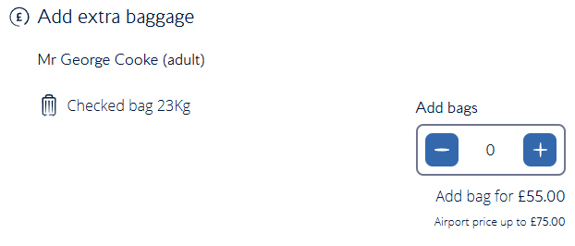
The next page shown to the right shows the extras a passenger can book for their flight (this is just any additional baggage they wish to bring). This is most likely stored as an integer field in the booking table.

The final page is a payment page. Data from this will not be stored in the database. In the most basic version of my website, this will only be validated and then nothing more will be done with it. One of my stretch aims is to then implement the Stripe Test API where payment information will be sent.

Data Processing

Searching
The main use of searching in the existing British Airways system is the searching of flight that fit the set criteria. This is most likely done through nested SQL select queries such as:

SELECT * FROM flights WHERE route_id = (SELECT route_id FROM routes WHERE departure_icao = … AND arrival_icao = … ) AND date = … ;

Sorting
A search for a flight between two airports can be sorted by the following options in the existing British Airways system:
- Recommended,
- Price (low to high),
- Shortest flight time,
- Earliest departure,
This may be done using the ORDER BY statement in an SQL query for shortest flight time and earliest departure. Price would be more complicated as this may be calculated dynamically for live pricing. This may require the price to be done on all flights that meet the search criteria and then a sorting algorithm performed on these prices. I would suggest that this may be a bubble or (more likely) and insertion sort as the data collection is not large enough to warrant a merge or quick sort.

Data Flow
I have made a Level 0 data flow diagram to help describe the relationship between entities and processes in the existing British Airways booking system when booking a flight (does not include searching for the flight). Beneath the DFD is an order list of operations/processes that happen.
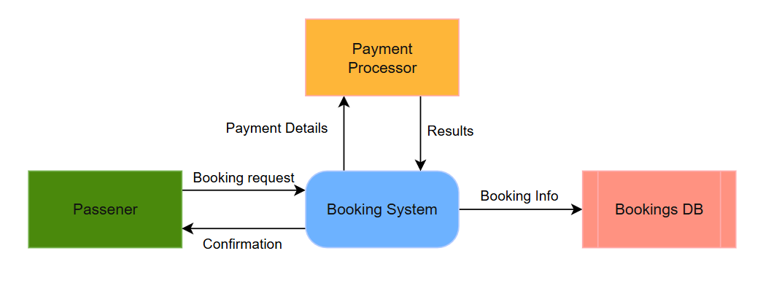
Order of operations:
- The user sends a request for a booking to the bookings system including their payment details,
- The booking system validates the booking information with the database to check that given seats are still available,
- If the seats are still available, they are booked,
  - Else an error is returned to the user,
- The booking system sends the payment details to the payment processor and charges the passenger,
- If the payment goes through, the user is shown and emailed a confirmation,
  - Else the system returns a payment error to the user and removes the bookings from the database,

Updated Limitations
Crew & Fleet Management
The system will always assume that there are sufficient aircraft at each airport to satisfy the flights scheduled. Flights will also not be automatically scheduled such that only one flight departs per flight that arrives. This will be the responsibility of the flight operations managers to coordinate. This could mean that routes, services, and flights are scheduled when there would be no aircraft at the location to service it.
The implementation of a fleet management system would be a great addition to this tool but likely falls outside of the scope of what is possible with the time allotted; this would be the workload of an entire extra project tacked on top of what is already likely to be quite a demanding project.
Similarly, I will not be managing staff rotas or assignment with this system. The system will assume that all aircraft will always be fully crewed and that all crew arrive on time (flight operations managers can manually delay flights if needed).

Handling Money
For obvious reasons, I will also not be handling any money with my system. This goes beyond what is needed for coursework and goes beyond my level of comfort. One of my stretch targets is to implement Stripe test mode for mock transactions. This will provide me with fake card details that will simulate successful, insufficiently funded, and declined transactions. This will put me as close to realism as is reasonable and (if this were ever to be converted to a program for a real client) allow for a quick and easy changeover by simply changing the API key.
Before I implement the Stripe API, there will also be no system for refunding flights. It will be assumed that a customer support representative cancelling a booking will lead to a refund through a separate system.

Online Access
This booking system will have to run as a website. This means that it will have to run on a server 24/7. This may place strain on the server at expense to the client if a large number of users are using the website simultaneously. During periods of strain, performance may also degrade leading to a worsened experience for users. Kubernetes and a load balancer could be used in a real-world situation to spread load between a collection of high-performance servers helping to ensure that all elements of the system have the resources they require but this would only be reasonable at a large scale that this project will not reach during testing.
There is also a risk of strain during scheduled tasks such as the creation of flight entries from schedules at a set time each day. When there are large quantities of services, this will likely place a lot of strain on the servers. In a real-world scenario, this may be placed on a separate server to prevent interruptions to guests.

Legal Compliance
The system will need to comply with the data protection legislation of the territories that it operates in. I will take measures to comply with many of these mandates, but a full independent review of data protection compliance would be required if this were a real product (see Discussion documentation for more details).
Mobile Interactions
While I will endeavour to make my web UI responsive to different screen sizes, I will not be making a standalone app. A standalone app could be helpful for the client as it would allow them to send notifications to prompt purchases (Pegasus Airlines saw that users who received push notifications purchased 72% more tickets – Source: dataroid). Building a custom mobile app falls significantly outside of the scope of this project as well as my current level of ability.

Detailed Business Analytics
The system will also not report on the profitability of flights as the costs will be unknown to it due to the ever-changing price of fuel and other operating expenses. Instead, it will only report the revenue of each flight. Flight operations managers, accountants, and executives will have to independently decide if they are worth continuing through their own calculations of profit.

Different Aircraft
Different aircraft in the real world have different seating capacities and layouts. I most likely will not be taking this into account in my system. This would be a feature that would add a lot to my project but may fall outside of what is possible in the time given. As such, I have added it as a stretch target to be pursued if time permits.

Surge Pricing
Surge pricing is commonly used within aviation to charge passengers as much as they are willing to pay so as to maximise profit for the airline. I will likely not be implementing this in my project. A part of my reasoning is that it may fall outside the scope of what is possible given the time available but the majority lies with the brand ethos of Infinity Airways. They are trying to target a wealthier clientele that are tired of the over commercialisation and gamification of the airline industry and dynamic pricing may not appeal to this cohort of people.

Email Integrations
All airlines use your email to contact you with updates for your flight, invoices, and boarding passes. I have added this as a stretch target for my program as it may not be feasible with the time given. Of the stretch targets, this is the one that I would like to include the most as I feel it would add a lot to my project.

Overweight Passengers
In the real world, if a passenger is significantly overweight they ay be requested to purchase an additional seat. This will likely not be possible in my system as each seat booked will require a unique passenger to be allocated to it.

Working Specification
I intend to build a booking website for the fictional airline “Infinity Airways”. The most critical functions are the adding of flights by flight operations managers and the subsequent booking of them by guests. These basic functions will be supported by the ability for flight operations mangers to schedule regular flights on a route and view statistics about existing routes. There will also be separate portals for check-in agents, gate agents, admin users, and customer support representatives. When booking seats, users will have the ability to add multiple passengers to their group and select specific seats out of those that are available from a graphical representation of the aircraft layout for each member of the group.

Justification of the Methods to be Used
For my project I have elected to build a website. This is because prospective guests will need to be able to book without access to local databases and without downloading an app.
To do this, I will be using Python as my primary language to create a Flask website. Within this website I will likely make use of JavaScript for internal API calls and some sorting (if deemed appropriate). I have chosen Python primarily because of my existing familiarity with it but also because of the extensive community support that is available due to its long history and widespread use. I will be using JavaScript as I will inevitably need to execute code within the browser.
For my package manager I will be using UV. One reason for this is its increased speed compared to pip. That said, my key justification is the ease in which I can use it to setup a virtual environment where my code will be run on a set version of Python and all of my libraries. This will ensure that an examiner has an accurate idea of how my app works without any unexpected issues that come from using it on a different machine (one example of where I’ve had an issue when not doing this before is when my personal computer and the school ones were using different versions of pyodbc which handled date datatypes differently.
To manage my database, I will employ alembic. This will allow me to use Object Relationship Mapping (ORM) for more streamlined data queries and use as well as autocomplete included in my IDE of choice (VS Code). This is a new technology that I used during some work experience and have been developing my understanding of over the past few months in personal projects. This is (apparently) also more inline with the practices used in industry and will thus further my education and prepare me for the workforce. I will pair this with alembic for database migrations to ensure that the database is setup consistently.

Updated Aims & Objectives
I have elected to write my aims and objectives in a tiered OKR format. This is used in a number of companies including Googe, Pinterest, and Intel for setting tiered objectives. While most software companies using OKRs elect to use a two-tiered approach, I prefer the three-tiered model that is more common in sales as it gives me a better idea of the priority of each of the different tasks.
Threshold tasks are the absolute bare minimum for the program to be functional. This is followed by target thresholds that I would complete in an ideal world but I recognise that it most likely will not be possible to complete all of them. Finally, I make note of my stretch targets. These are the aims and objectives that address many of the limitations of the system listed above. I do not expect it to be possible to complete any of the stretch but would be my next steps if I were to continue the project or have additional time at the end. They can also provide additional tasks that I can switch to if I find my motivation waning as I work through the more basic aims and objectives under the threshold and target umbrellas. I expect to complete 70-90% of the threshold and target aims and objectives and very few (if any) of the stretch aims and objectives.

Threshold (MVP):
1. Flight Operations Managers can add flights
Flight operations managers should have a separate portal from guests and should be able to add standalone flights.

2. Guests can book flights
This is dependent on objective 1. Guests should be able to view all available flights, select one, and book it. They do not need to be able to make an account to satisfy this objective. Flights do not necessarily have to be available in one list to satisfy this objective (see objective 12).

3. Brought together with an appropriate GUI
Objectives 1 and 2 must be able to be completed on a website. This will enable guests to book online without the need to download a standalone app thus increasing the chance of a purchase.

4. Make use of a database containing 4 tables in third normal form
This is a requirement for the project to qualify as an A-Level NEA. This project must make use of a database in (at least) third normal form with (at least) four tables.

Target:
5. Guest user accounts
This builds on objective 2 by allowing guests to create an account. This will allow them to view a history of previously booked flights and save data to be auto filled when booking future flights.

6. Customer support representative accounts & portal
This is dependent on objective 5. When a guest creates an account, they should be assigned a customer support representative. This representative should be able to view and edit information about a guest’s bookings.

7. Check-in & gate agent accounts & portal
Check-in and gate agents should be assigned to a specific airport and be able to view all flights active for the given date and time. They should then be able to view the passengers on each of those flights and mark them as arrived, bags checked, boarded, etc. Check-in agents should be able to take passport details (a required step before marking a guest as arrived).
While these two account types fall under one objective, they should each have their own portal (although they will most likely be very similar).

8. Flight Operations Managers have to log in to access portal
This builds on objective 1 by forcing flight operations managers to verify their identity before they can make changes by logging in with a username and password. This will make the program more secure and prevent the general public from having unadulterated access to the inner workings of the airline which could cause havoc.

9. Admin accounts & portal
Admin users should have their own accounts and a portal that allows them to add, edit, and delete staff accounts including changing the privileges of them (such as adding the ability to offer upgrades to a check-in agent). They should also be able to view and delete guest accounts. Finally, admin accounts should have access to the portal of all other staff users.

10. Use secure login using user sessions
This objective builds on objectives 5, 6, 7, 8, and 9. The program should use Flask’s build in session functionality so that users do not have to repeatedly log in every time they use the website. This will also mean that I don’t have to put IDs in the URL (as I had been doing previously) which will be substantially more secure.

11. Repeating flight scheduling functionality
This builds on objective 1. Flight operations managers should be able to set up, manage, and delete schedules for flights between two points (routes) that repeat without needing to manually add new flights.

12. Guests can search for flights
This builds on objective 2. Guests should be able to search the list of flights for any that match the criteria they are looking for (search by: origin, destination, and date. Always filter so that only flights with available seats are shown).

13. Flight operations managers can see performance of flights / routes / services over time
This builds on objectives 1 and 11. Flight operations managers should be able to view statistics of previous flight / route / schedule performance so that they can make better informed decisions in the future. For example: they should be able to see the average proportion of seats occupied on each schedule slot of a route.

14. Guests can specify the seat they want to book within the GUI
Guests should be able to view a seat map of the aircraft colour coded with availability when booking and select a specific seat for their journey. Guests should only be able to book available seats.

15. Guests can specify the identities of other passengers in their group
Guests should be able to add multiple passengers to their group and give the required details for their booking.

Stretch:
16. Email Integration
This builds on objective 5. Guests should be sent an email confirmation email when setting up an account and should be able to reset password though an email when forgotten.

17. PDF boarding pass is generated
This builds on objectives 2 and 16. The system should generate a PDF boarding pass that is automatically emails to the guest on checkout. It should also be downloadable after the fact from the guest portal if the guest it logged in at checkout. Staff such as check-in agents and customer support representatives should also have access to the boarding pass. The guest should be emailed an updated boarding pass on any changes to their booking (for example: a change in the departure time triggered by a Flight Operations Manager).

18. Use Stripe test mode for mock financial transactions
The program should use the Stripe test API at checkout. This will provide realistic payment responses that the program should be able to handle.

19. Flight operations users can add articles for destinations
Guests should be able to add and edit articles for destinations. These articles should have links that direct a user to book a flight to this destination.

20. Similar flights section
The program should display a “Similar Flights” section when searching for a flight that shows flights from nearby destinations. This should be sorted using a quick sort algorithm to show which routes are closest to the searched route.

21. Add surge / dynamic pricing
Prices should be dynamic based on time until departure, rate of purchase, and seats available. Flight operations mcanagers should be able to set a minimum and maximum price for the route.

23. Staff accounts can interact with the guest portal
Staff users should be able to log on to the guest portal and make bookings. They should then receive discounts on the price of the flight.

24. Different aircraft configurations have different seat maps
Routes should be assigned and aircraft type. Each aircraft type should have its own seating capacity and seating map for booking.

25. Guests should be able to request a refund
Guests should be able to cancel a flight and/or request a refund through the online portal or by contacting their customer support representative.

